Phonetics
- [əʊ] Snow in October (Sheep or Ship, pdf p. 79)
- [ŋ] What are you doing on holidays darling? (Ship or Sheep for Kids)
- [w] What do you want for your birthday?

Grammar
- Present Simple vs Present Continuous (PB p. 45)
- Degrees of Comparison: the comparative degree (PB p. 51)
- Degrees of Comparison: the superlative degree (PB p. 53)
- There was/There were (PB p. 65)
- Past Simple: the use, formulas (+, -, ?), spelling (PB p. 71 )

Topic (dialogues): PB Units 7, 8, 10, 11, 12 pp. 44, 50, 62, 64, 70, 76
Vocabulary: PB Units 7, 8, 10, 11, 12 pp. 44, 46, 50, 52, 62, 64, 70, 72, 76, 78
Speaking: find the differences (Task 1 from Movers)
Phonetics:

[əʊ]
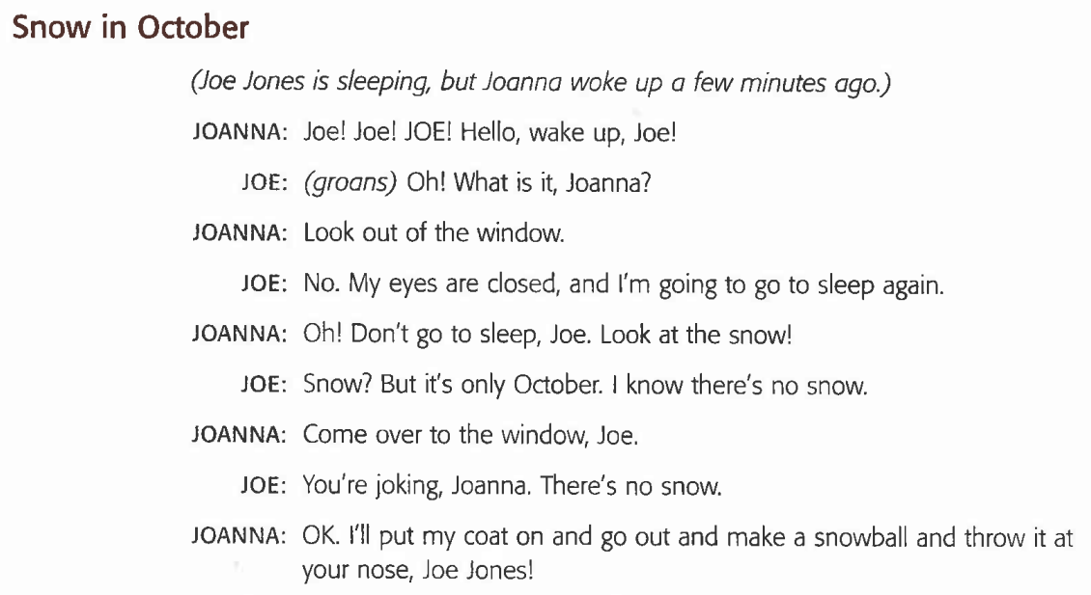

[ŋ]

- What are you doing on holidays, darling?
- I’m thinking about going to Paris.
- Paris! How interesting! What are you planning to do there?
- Walking, eating, drinking, having a good time, just relaxing.
- Ah! How charming!

[w]
- What do you want for your birthday?
- Whatever you want to give me.
- A watch? A wallet? A wig? A welcome mat? A woolly vest? Some waffles? A whale? A watermelon?
- Whatever!

GRAMMAR

Present Simple Vs. Present Continuous
We use Present Continuous for actions happening now, at the moment. | We use Present Simple for actions that we do often, every day.
In positive (+) sentences we use:  Subject + to be (am, is, are) + verb + ing  He is reading now. | In positive (+) sentences we use:  Subject (I, we, you, they) + verb  I play computer games every day.  Subject (he, she, it) + verb + s  He plays computer games every day.
In negative (-) sentences we use:  Subject + to be (am, is, are) + not + verb + ing  He is not reading now. | In negative (-) sentences we use:  Subject (I, we, you, they) + do + not + verb  I don’t play computer games every day.  Subject (he, she, it) + does + not + verb  He doesn’t play computer games every day.
In questions (?) we use:  to be (am, is, are) + subject + verb + ing  Is he reading now? | In questions (?) we use:  Do + subject (I, we, you, they) + verb  Do I play computer games every day?  Does + subject (he, she, it) + verb  Does he play computer games every day?
Short answers:  Yes, I am. / No, I’m not.  Yes, he is. / No, he isn’t.  Yes, we are. / No, we aren’t. | Short answers:  Yes, I (we, you, they) do.  No, I (we, you, they) don’t.  Yes, he (she, it) does.  No, he (she, it) doesn’t.
The time markers (указатели времени) for Present Continuous are now, today, at the moment. | The time markers (указатели времени) for Present Simple are always, usually, often, every day.

Comparatives and Superlatives

Comparatives (сравнительная степень прилагательных) + than используется для сравнения 2-х людей/ предметов/ мест.

Adjectives | Positive | Comparative
one syllable  (1 слог) | fat  old  nice  cheap | fatter than  older than  nicer than  cheaper than
two syllables ending in –y  (2 слога, заканчивающиеся на –y) | happy  heavy  easy | happier than  heavier than  easier than
more than two syllables  (больше чем 2 слога) | interesting  beautiful  boring | more interesting than  more beautiful than  more boring than

For example:
The cow is fatter than goats.
Elephants are bigger than monkeys.

Spelling (правила правописания):
- «+r» Если односложное прилагательное заканчивается на –е, то прибавляем только –r: nice – nicer than.
- «1+1» Если в слове 1 слог, последняя 1 согласная, а перед ней 1 гласная, то последняя согласная удваивается: big – bigger than.
- «+ier» Если односложное прилагательное заканчивается на согласную +y, то -y убираем и прибавляем –ier: happy – happier than.

Superlatives (превосходная степень прилагательных) используется, чтобы сказать, что 1 человек/ предмет/ место самый-самый.
Adjectives | Positive | Comparative | Superlative
one syllable  (1 слог) | fat  old  nice  cheap | fatter than  older than  nicer than  cheaper than | the fattest  the oldest  the nicest  the cheapest
two syllables ending in –y  (2 слог, заканчивающиеся на –y) | happy  heavy  easy | happier than  heavier than  easier than | the happiest  the heaviest  the easiest
more than two syllables | interesting  beautiful  boring | more interesting than  more beautiful than  more boring than | the most interesting  the most beautiful  the most boring

Spelling (правила правописания):
- «+st»
- «1+1»
- «+iest»

Исключения:
Positive | Comparative | Superlative
good  bad  little  many/a lot  much | better than  worse than  less than  more than  more than | the best  the worst  the least  the most  the most
There was / There were
We use There was / There were when we say that something was somewhere.  There was / There were + thing + place  We use There was with singular nouns.  There was a book on the table.  We use There were with plural nouns.  There were fourteen presents. | Мы используем There was / There were, когда мы говорим, что что-то где-то находилось.  There was / There were + вещь + место  Мы используем There was с именами существительными в единственном числе.  На столе лежала книга.  Мы используем There were с именами существительными во множественном числе.  Здесь было четырнадцать подарков.
In positive sentences (+) we use:  There was / were + subject + place  There was milk in the fridge. | В утвердительных предложениях (+) мы используем:  There was / were + подлежащее + место  В холодильнике было молоко.
In negative sentences (-) we use:  There was / were + not + subject + place  There was not milk in the fridge. | В отрицательных предложениях (-) мы используем:  There was / were + not + подлежащее + место  В холодильнике не было молока.
In questions (?) we use:  Was / were there + subject + place?  Was there milk in the fridge? | В вопросительных предложениях (?) мы используем:  Was / Were there + подлежащее + место?  Было ли в холодильнике молоко?
! На русский язык такие предложения мы переводим с конца !

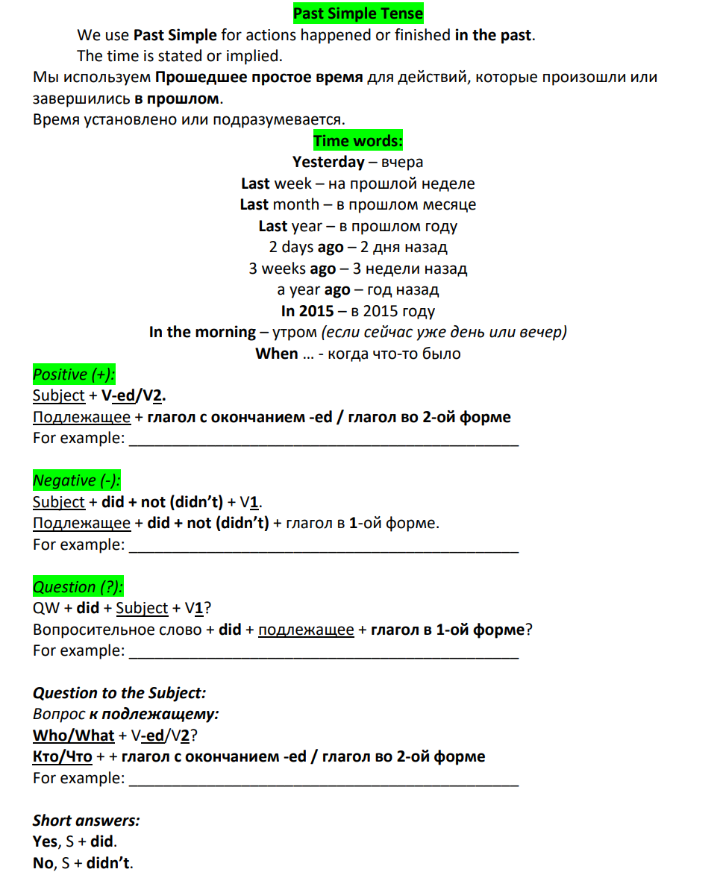

Reading rule:
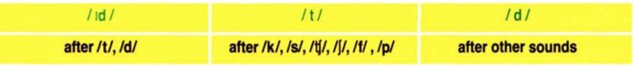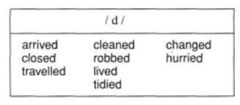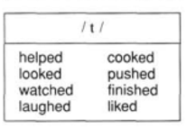

Vocabulary List
Unit 7 |  | Unit 10
job | работа | naughty | вредный, капризный
bus driver | водитель автобуса | cute | милый
pilot | пилот | noisy | шумный
DJ | диджей | circus | цирк
baker | пекарь | quiet | спокойный
farmer | фермер | dirty | грязный
fire | огонь | show | показывать
firefighter | пожарник | post office | почта
deliver | доставлять | library | библиотека
postman | почтальон | hospital | больница
cycle | кататься на велосипеде | greengrocer’s | овощной магазин
skate | кататься на коньках | butcher’s | мясной магазин
skip | прыгать (со скакалкой) | museum | музей
walk | ходить, гулять | baker’s | пекарня
stamp | марка | police station | полицейский участок
collect | собирать | town | небольшой город
coin | монета | Unit 11
baseball | бейсбол | sports programme | спортивная программа
model aeroplane | модель самолёта | boxing | бокс
Unit 8 |  | comedy | комедия
grass | трава | quiz show | квиз шоу
wool | шерсть | the news | новости
field | поле | cartoon | мультик
cowboy | ковбой | study | учиться
sheep | овца | computer game | компьютерная игра
bird | птица | video | видео
cow | корова | ring | кольцо
snail | улитка | seal | тюлень
chicken | курица | bounce | подпрыгивать
goat | козёл | seesaw | качели-балансиры
duck | утка | clap | хлопать
farm | ферма | kick | пинать, ударять ногой
slow | медленный | laugh | смеяться
cheetah | гепард | land | приземляться
grassland | луг | bucket | ведро
country | страна | Unit 12
turtle | черепаха | cave | пещера
world | мир | caveman | пещерный человек
forest | лес | strong | сильный
python | питон | stone | камень
jungle | джунгли | dinosaur | динозавр
leaf | лист | hunt | охотиться
bamboo | бамбук | weapon | оружие
whale | кит | tool | инструмент
sea | море | animal skin | кожа животного
 |  | wood | дерево (материал)
statue | статуя
bone | кость
Egypt | Eгипет
wing | крыло
beak | клюв
sun | солнце
cloud | облако
dust | пыль
comet | комета
hit | ударять
sharp claws | острые когти
neck | шея
earth | Земля

